**CLOUD**

1. **EC2**

First, after login to the AWS services, click on EC2 services and then click on the Launch Instance.

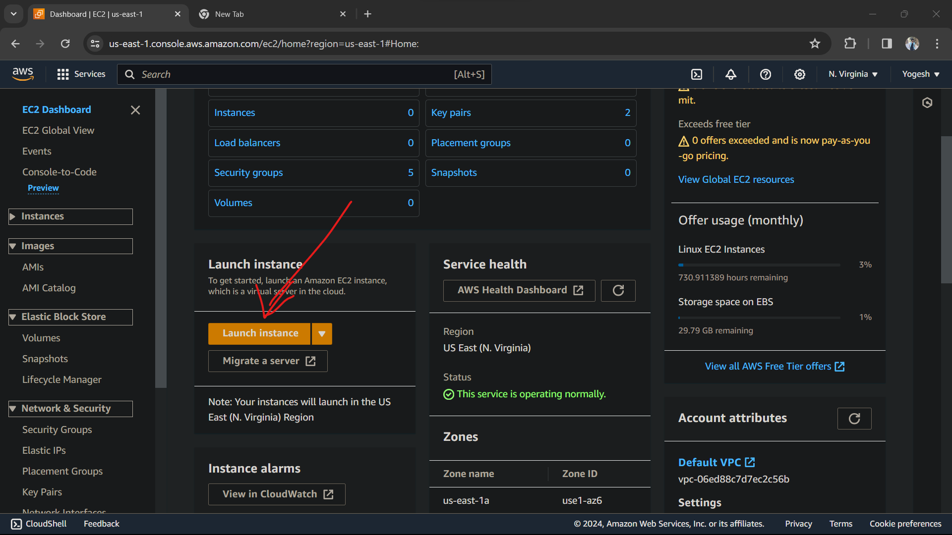

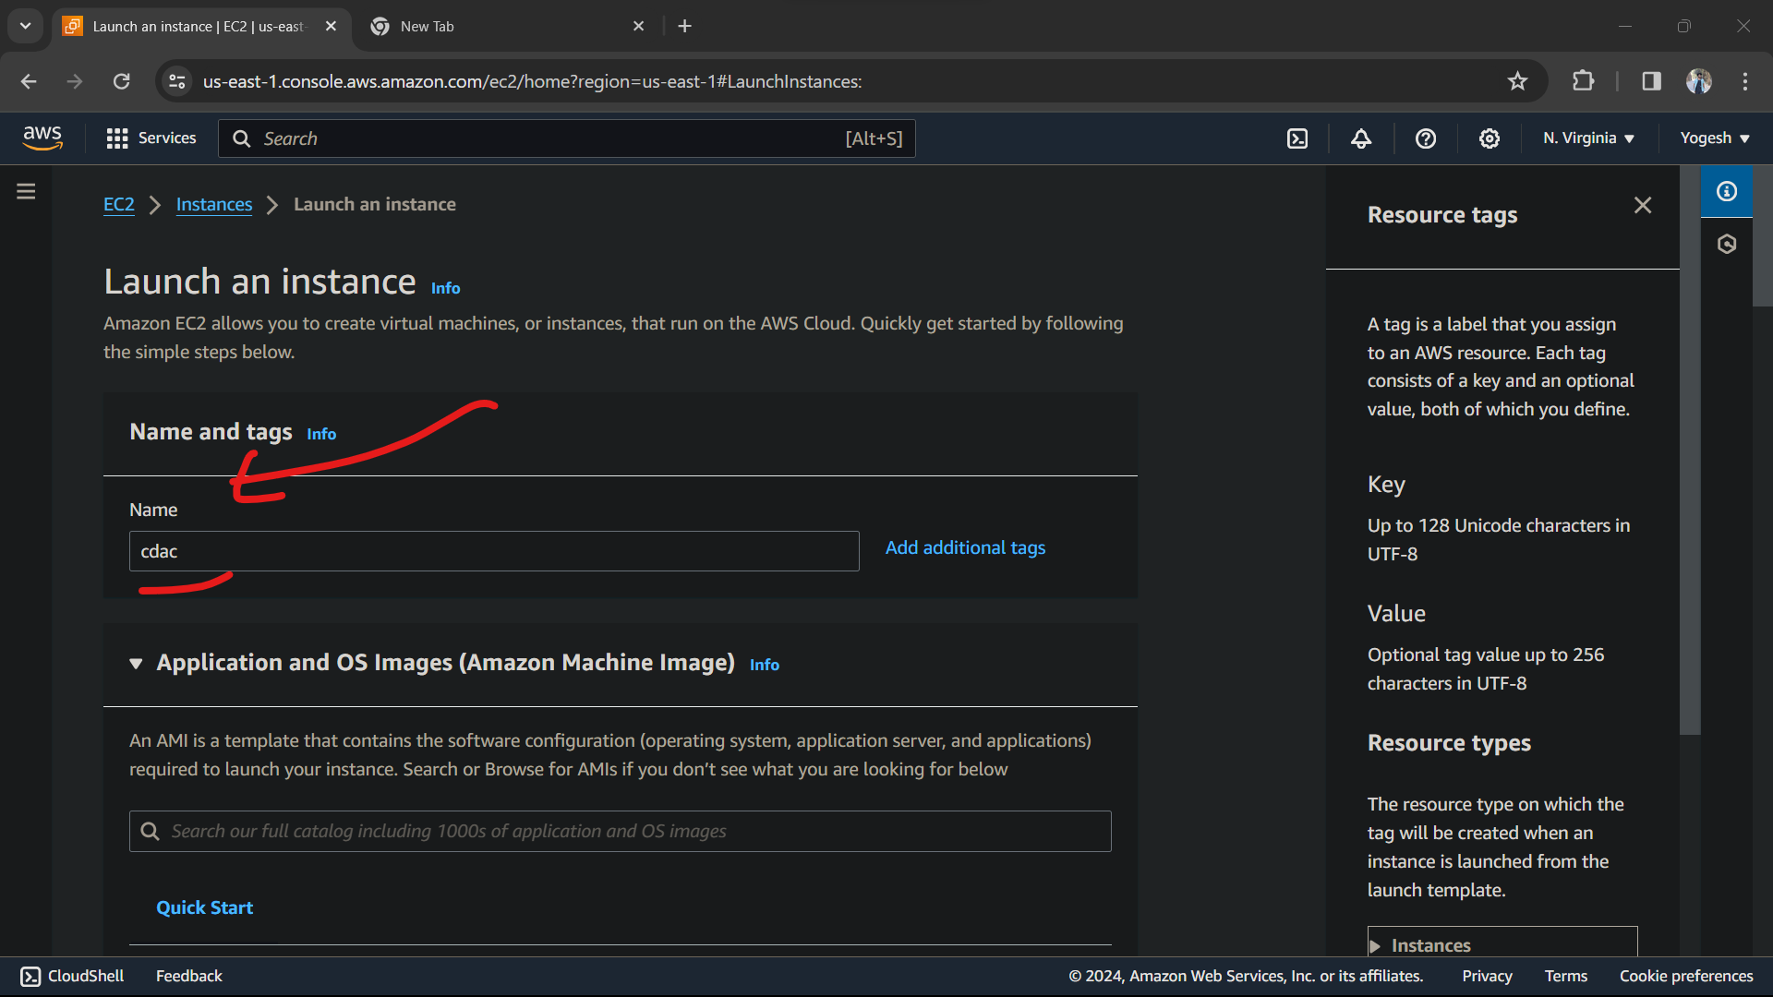

Here, we have to give a name and tags for EC2 instance.

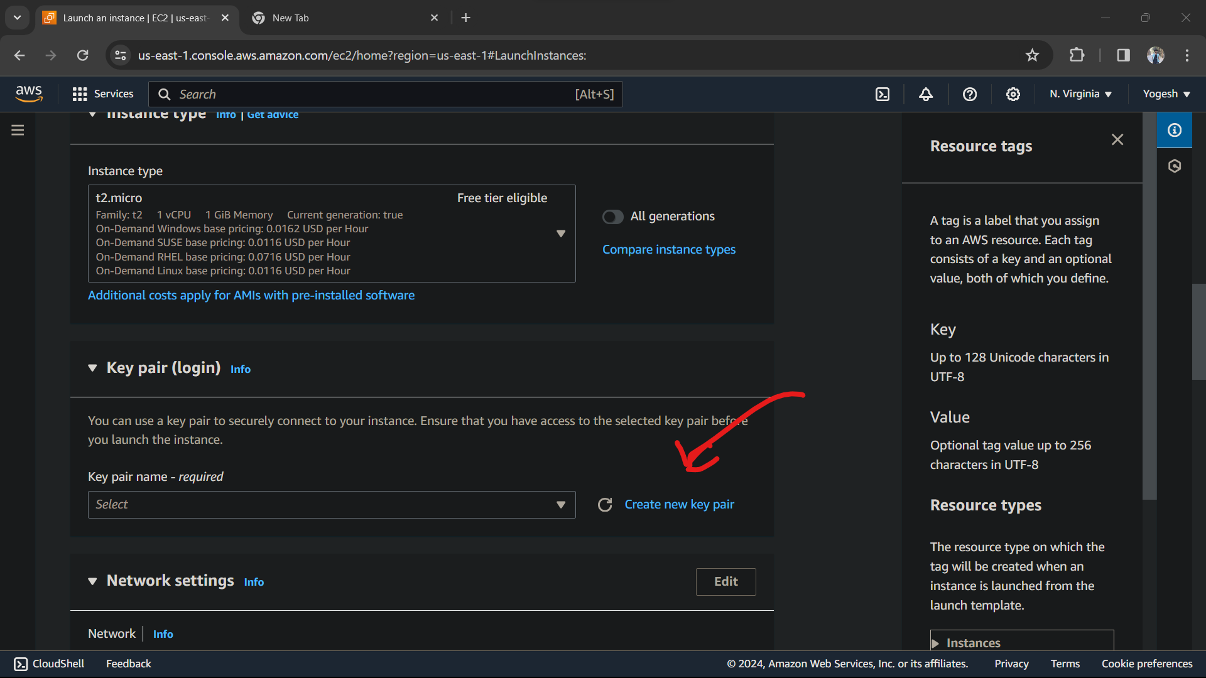

After scrolling down, we have to create new key pair

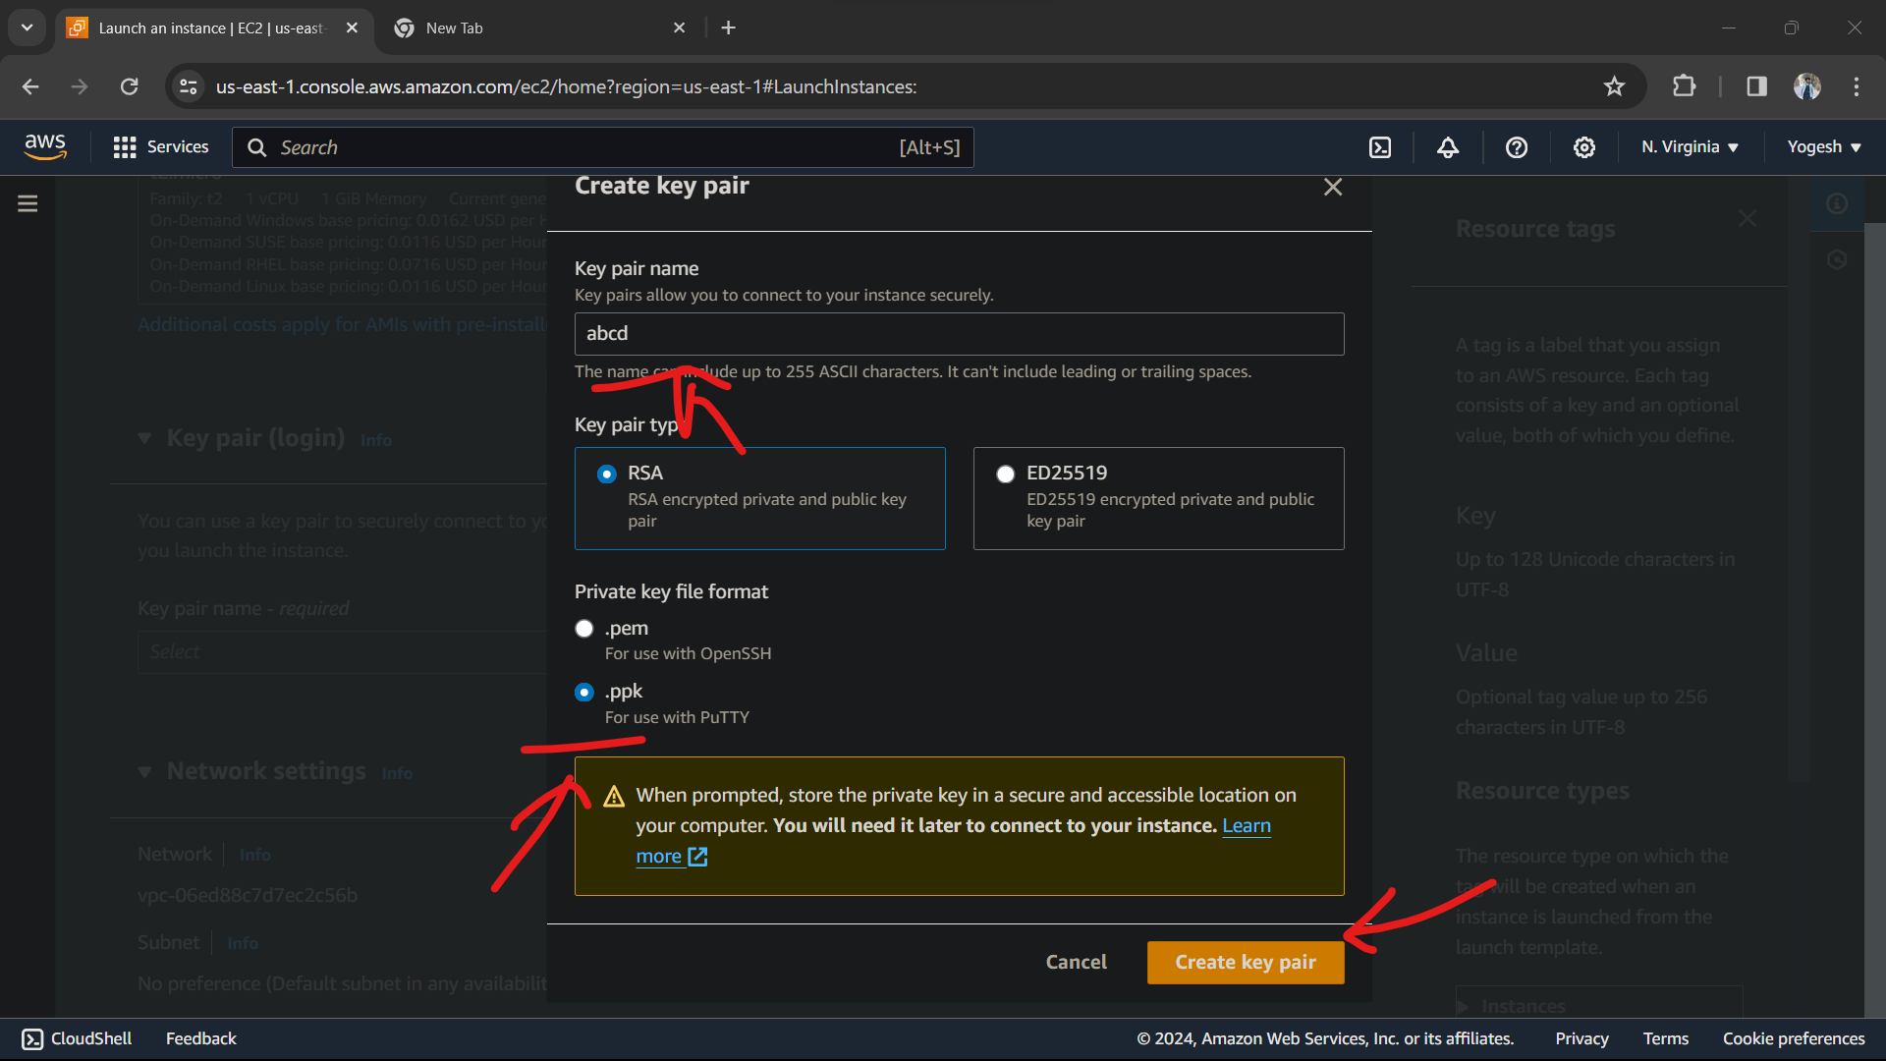

We have to give a name for key pair, and then we have to choose .ppk extension file for PuTTY.

And then click on Create key pair

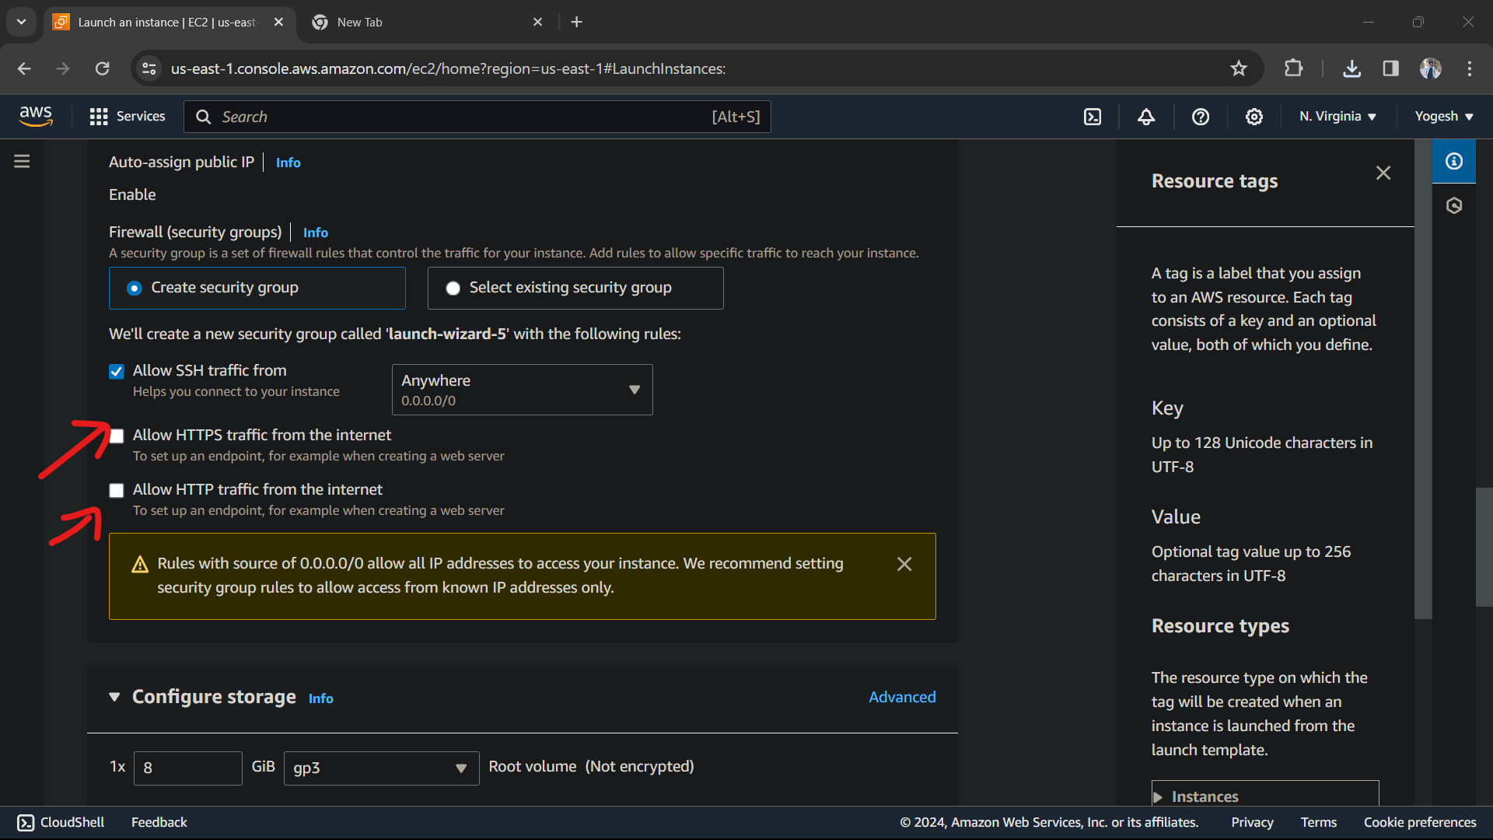

After creating a key pair, we have to allow HTTPS traffic from the internet and also allow HTTP traffic from the internet.

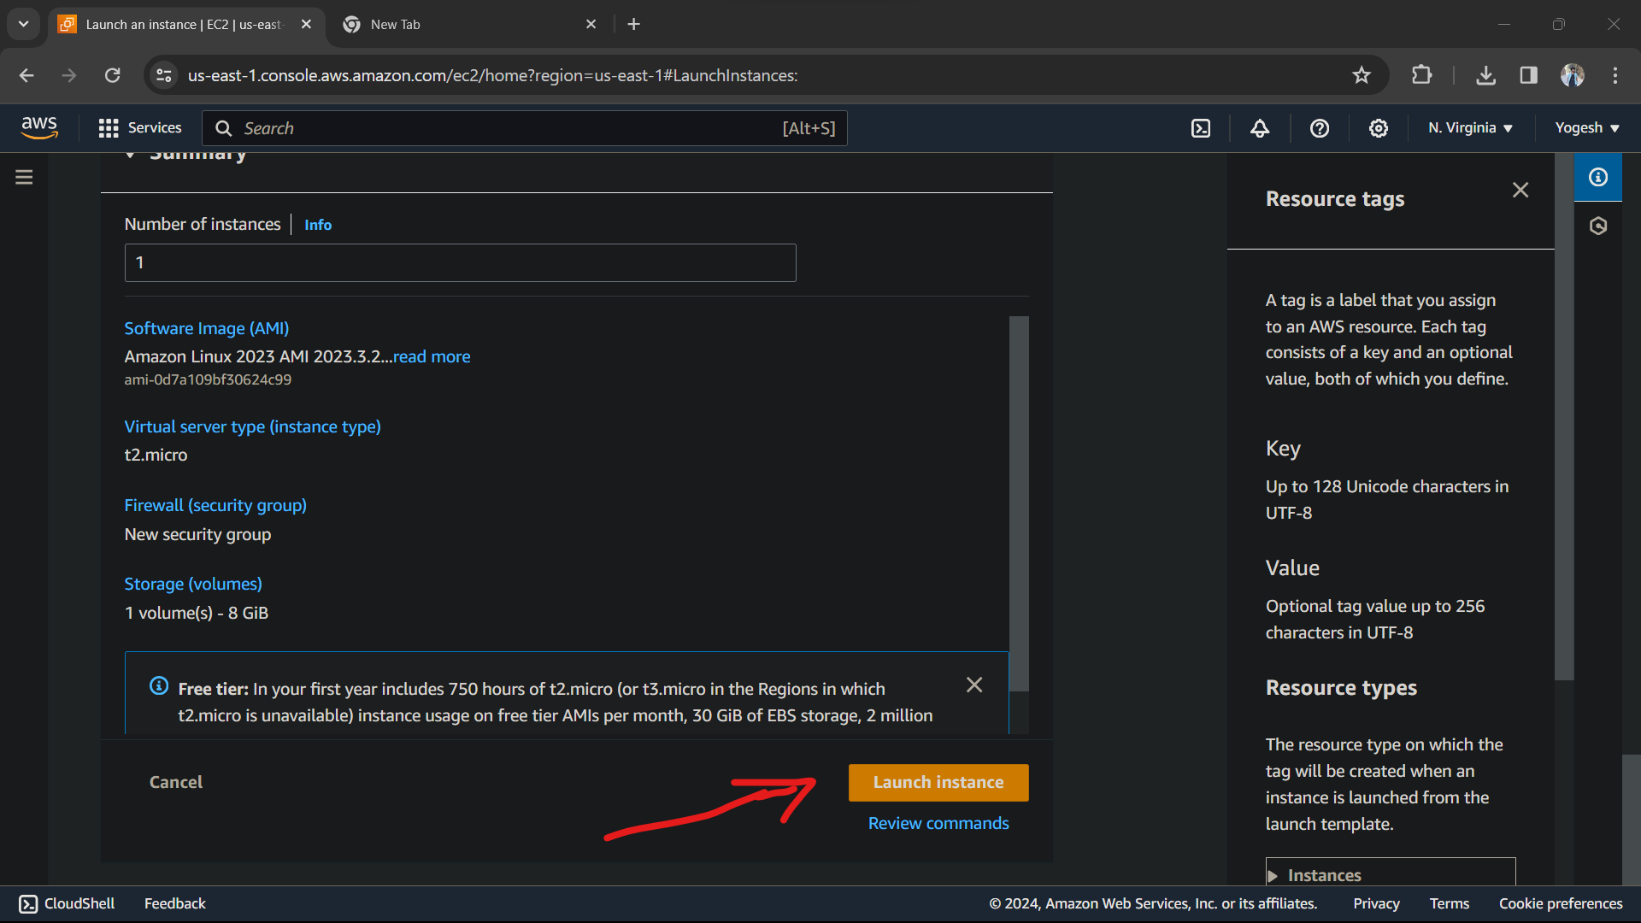

And then we have to click on Launch Instance. The instance will be created by given id, just click on it.

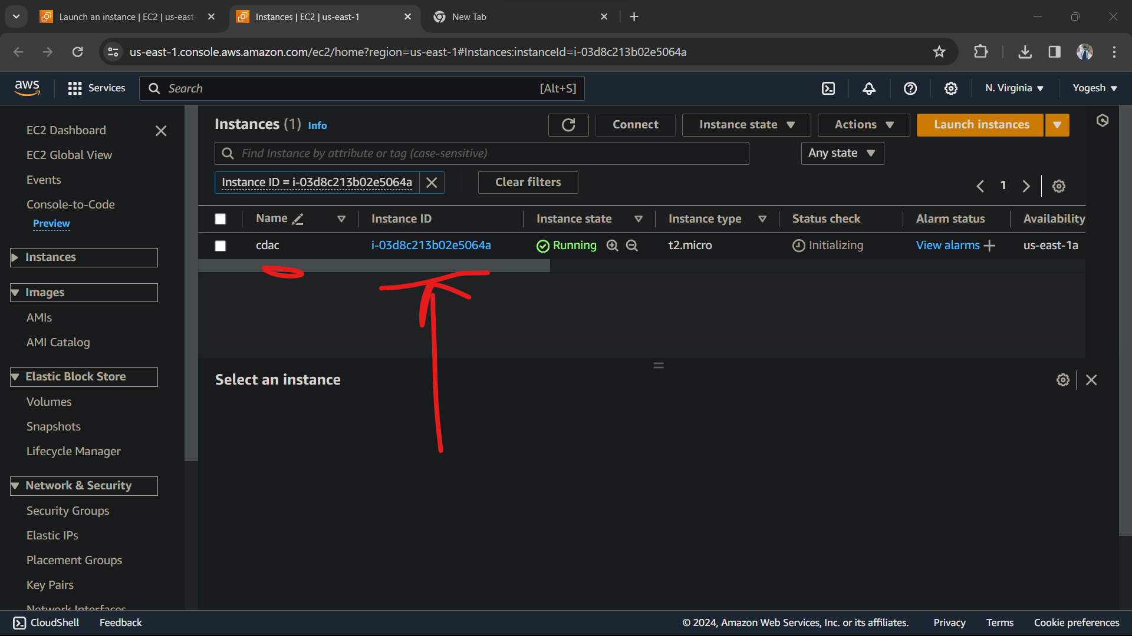

Now, Instance is created with Instance ID. Just click on it. Make sure that Instance state is running.

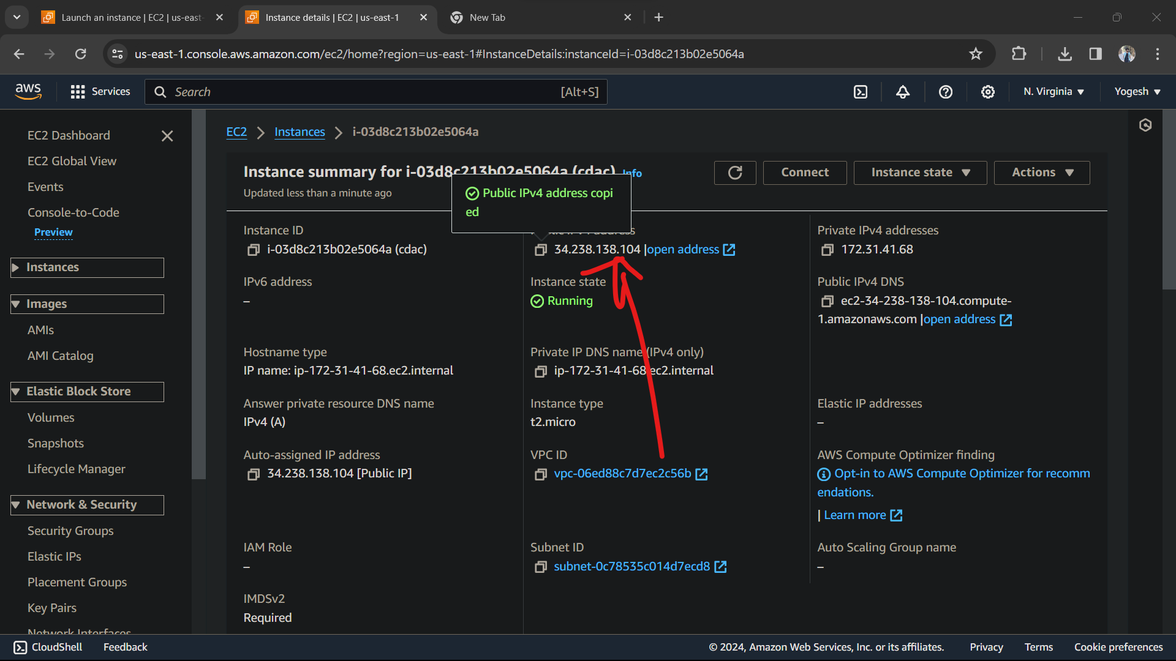

We can see Public IPv4 address is generated, we have to copy that and then open PuTTY.

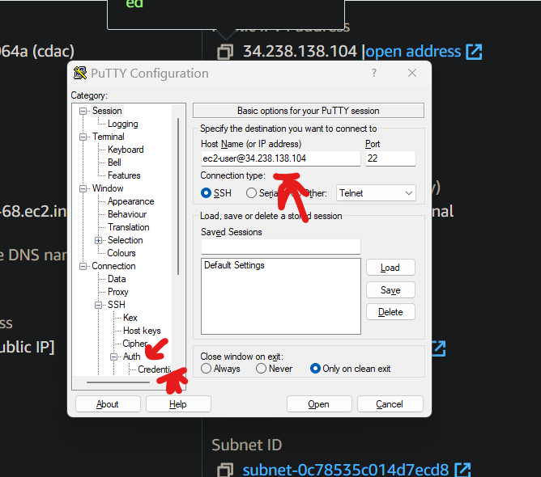

Here, enter Hostname and then we have click on SSH and then on Auth and then Credentials.

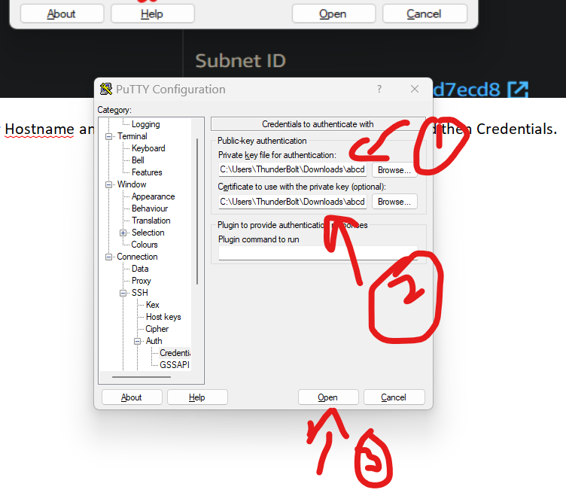

Then we have to give path as shown in the above figure while following the steps and then click on open.

PuTTy server will be opened like this given below.

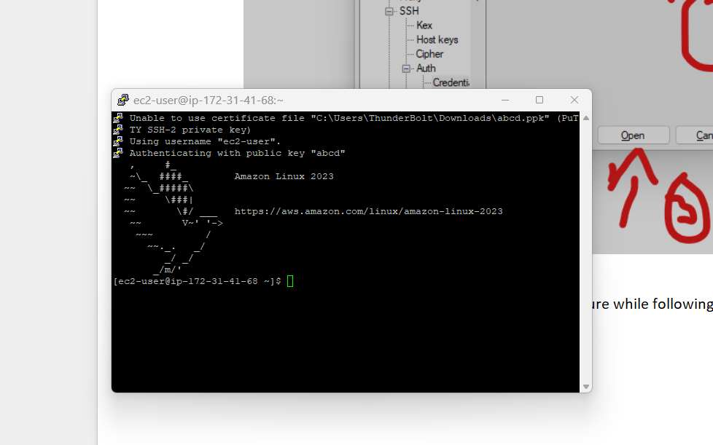

Then we have to enter commands like :

sudo -I

yum update -y

yum install httpd -y

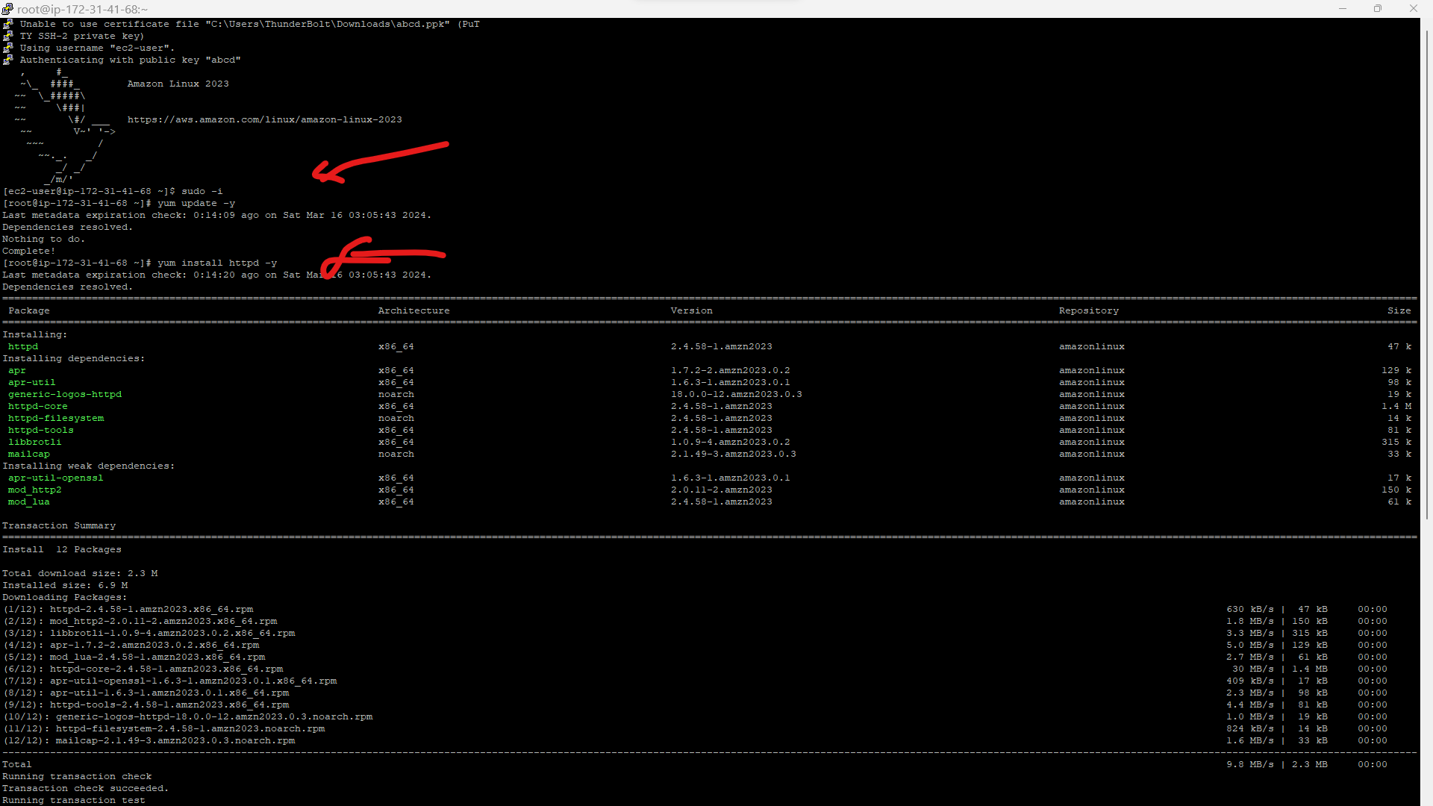

systemctl start httpd

systemctl status httpd

systemctl enable httpd

cd /var/www/html

ls

vi index.html

cat index.html

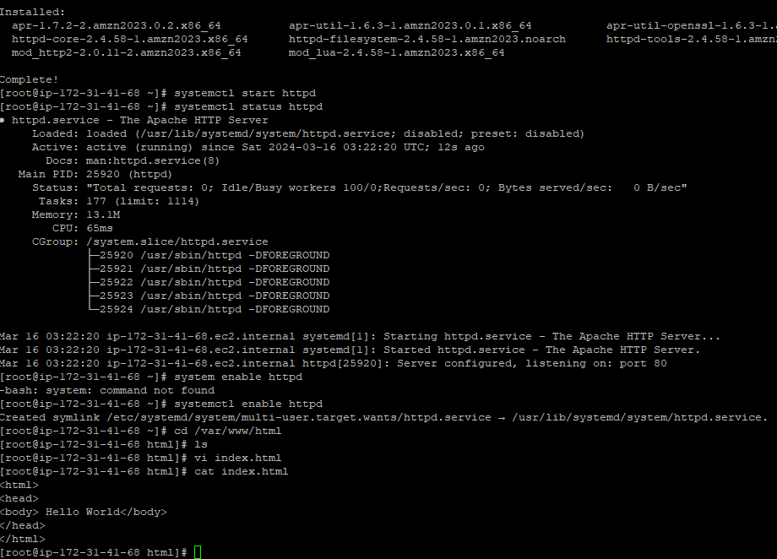

After that copy the IPv4 address and paste it on browser tab.

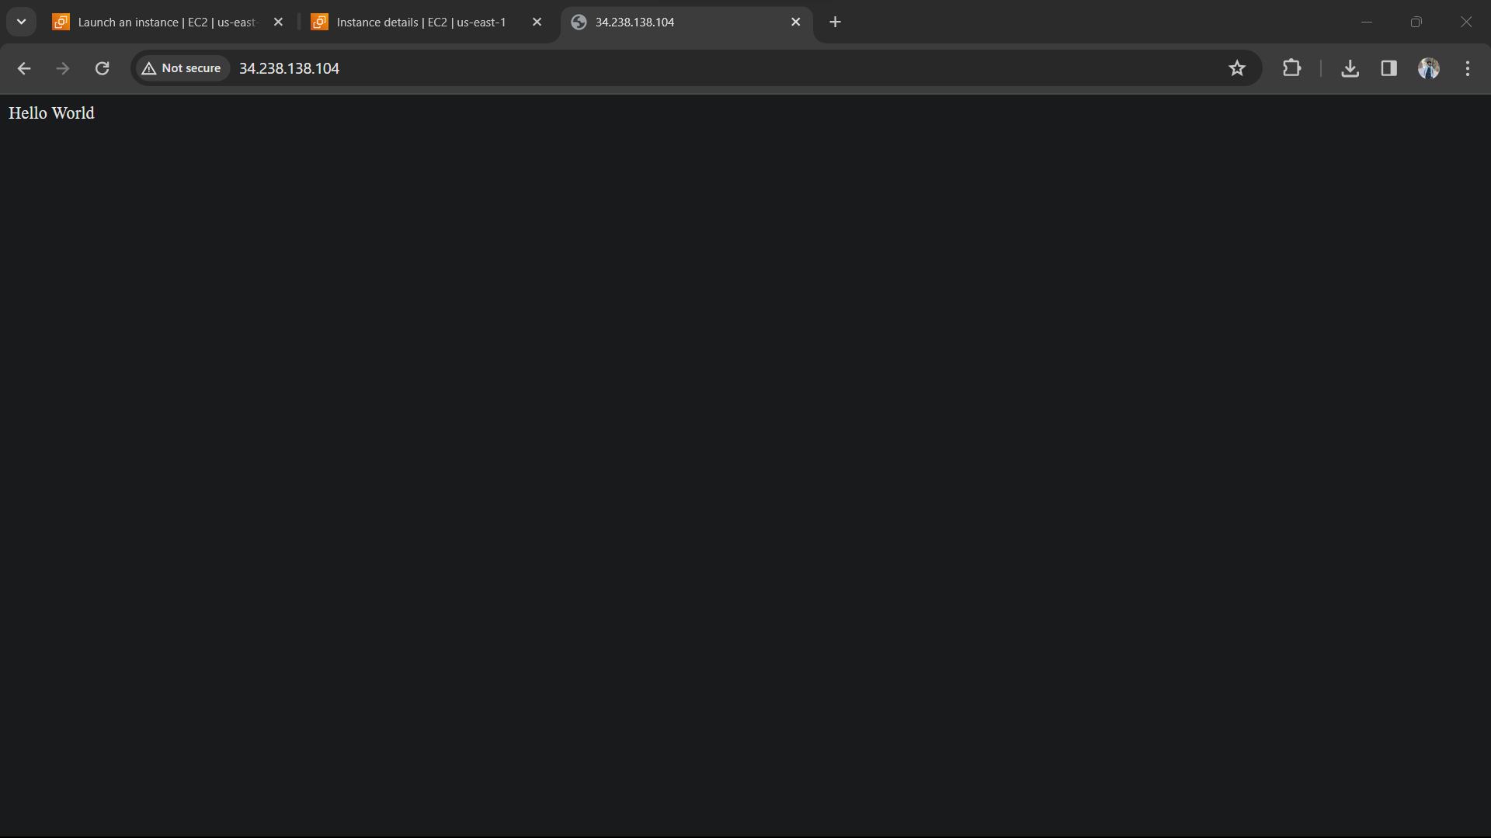

Its working.

**S3**

Click on create a bucket and then give a name to it.

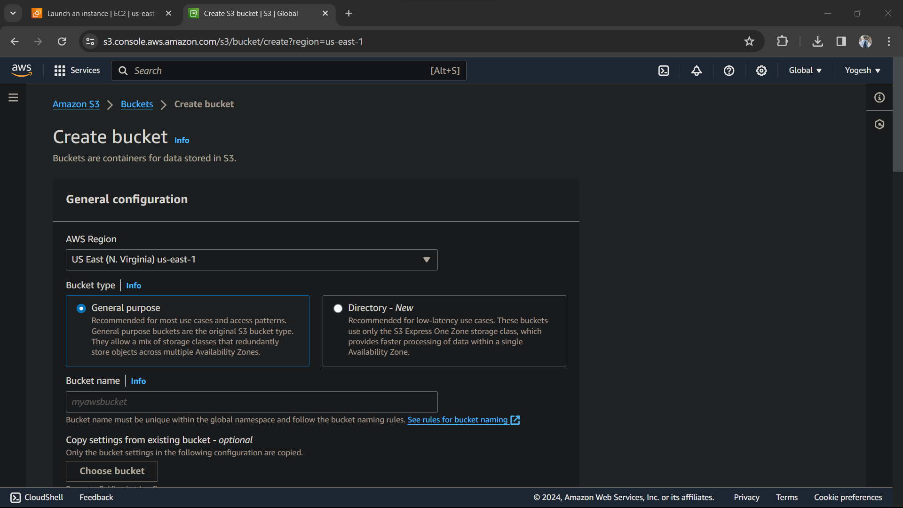

Then click on ACL Enabled

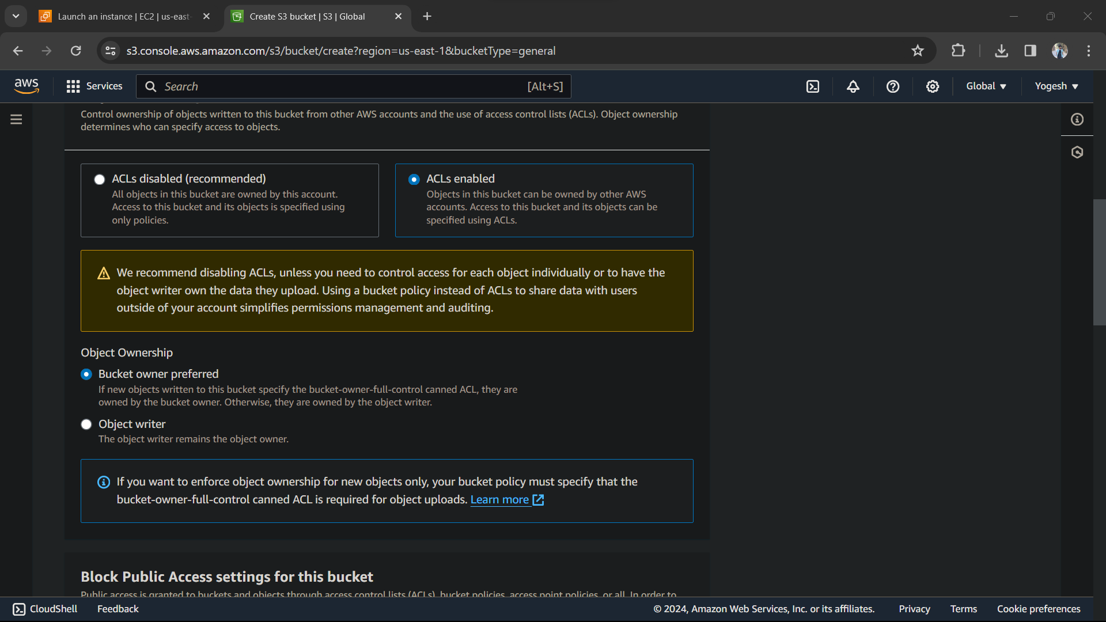

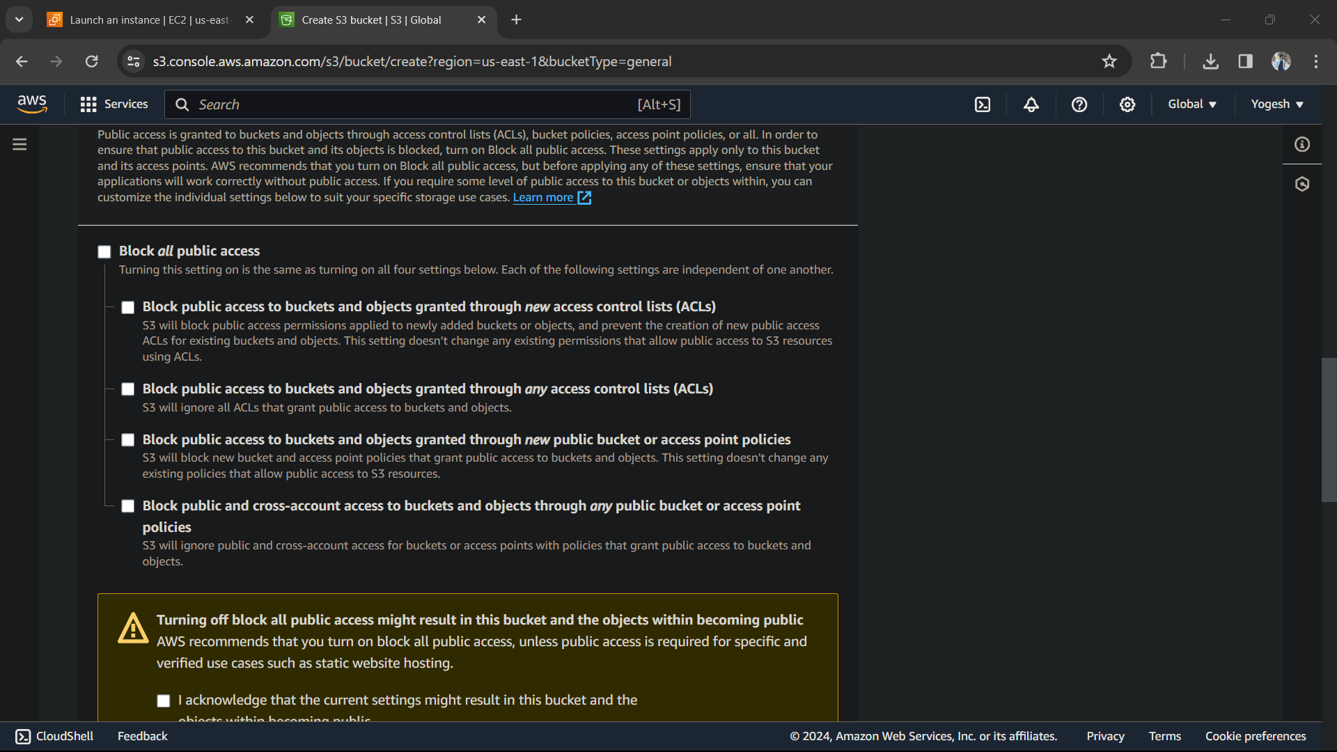

Remove Block all public access and click on I acknowledge

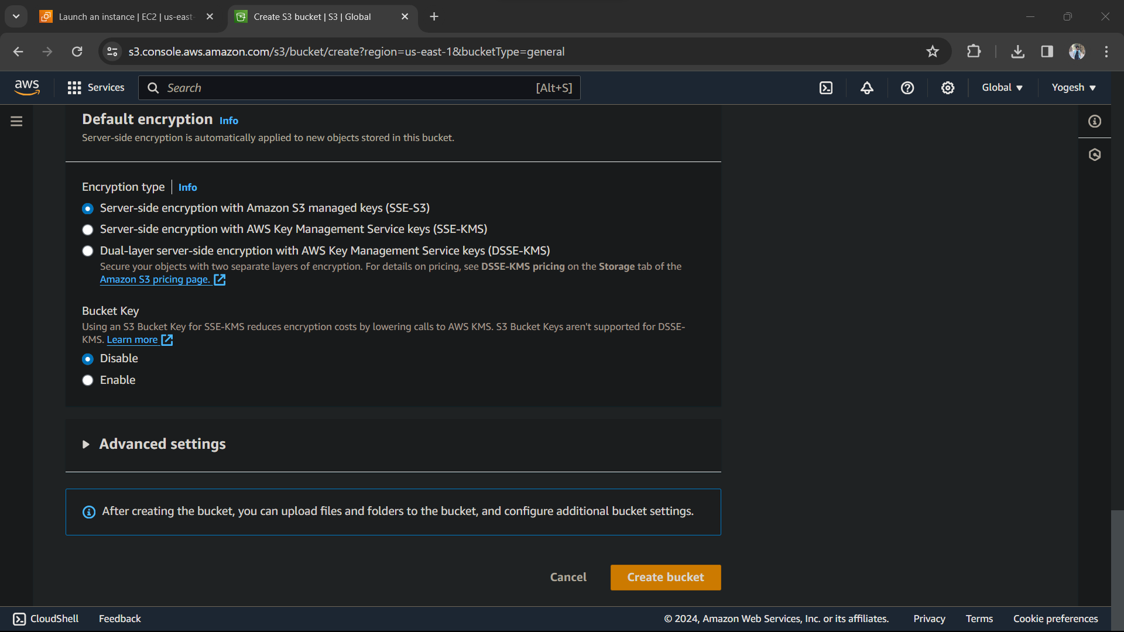

Remove bucket key and then click on Create bucket.

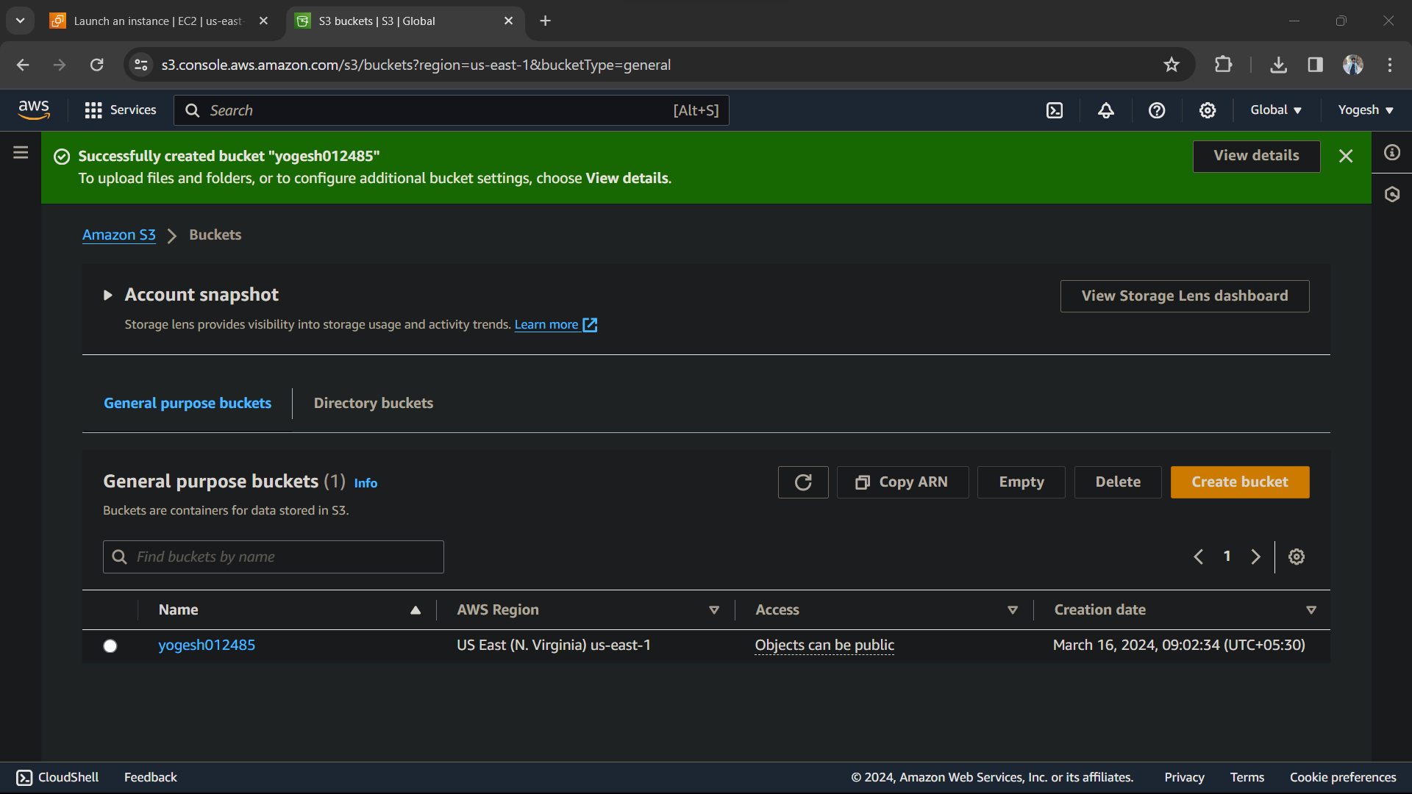

Bucket is created, now click on your bucket .

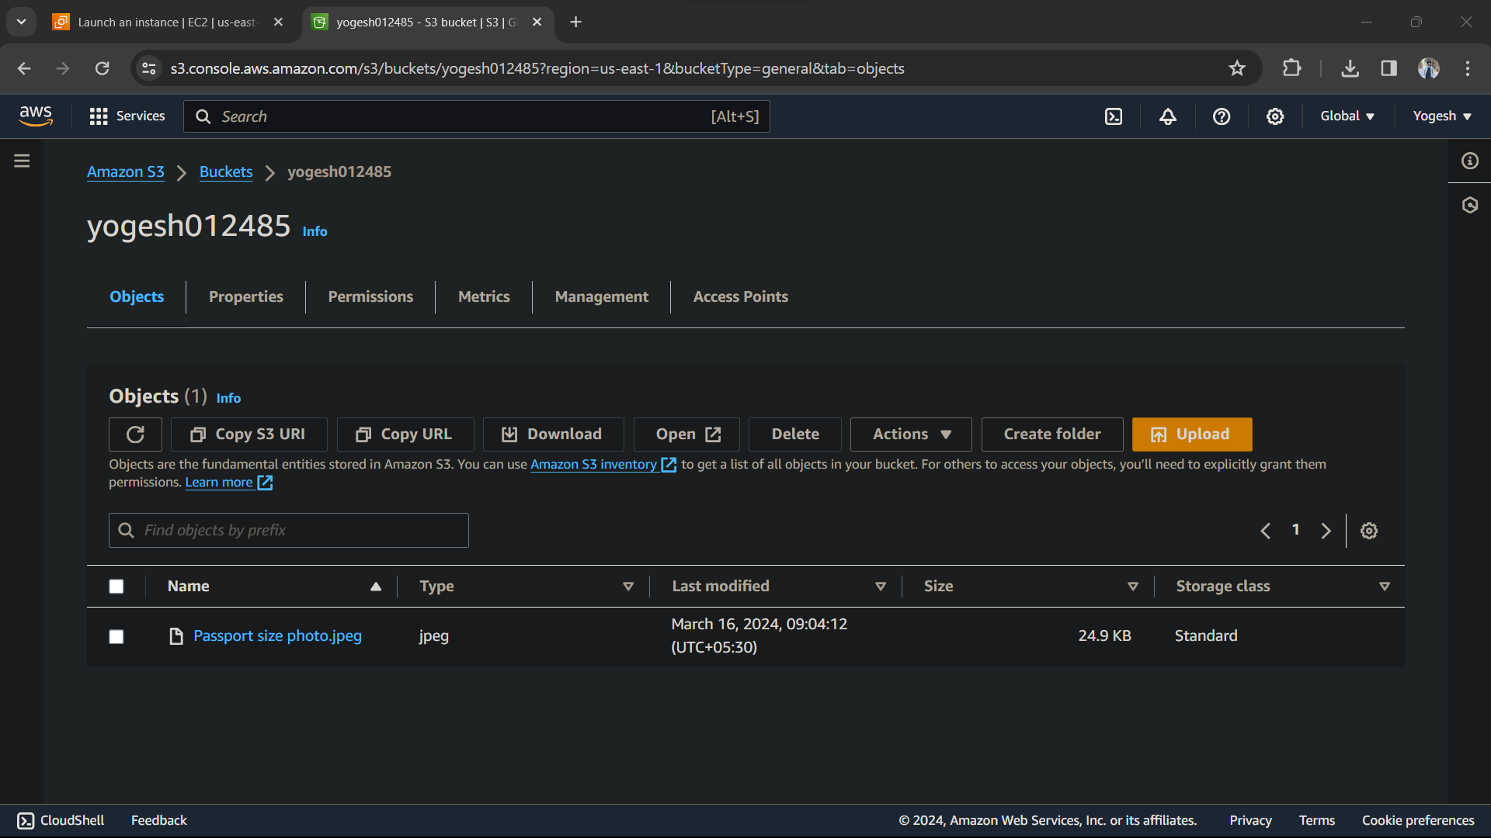

Basically we have to upload any file here. As you can see , I have uploaded a image.

Then click on Permission and then go to ACL.

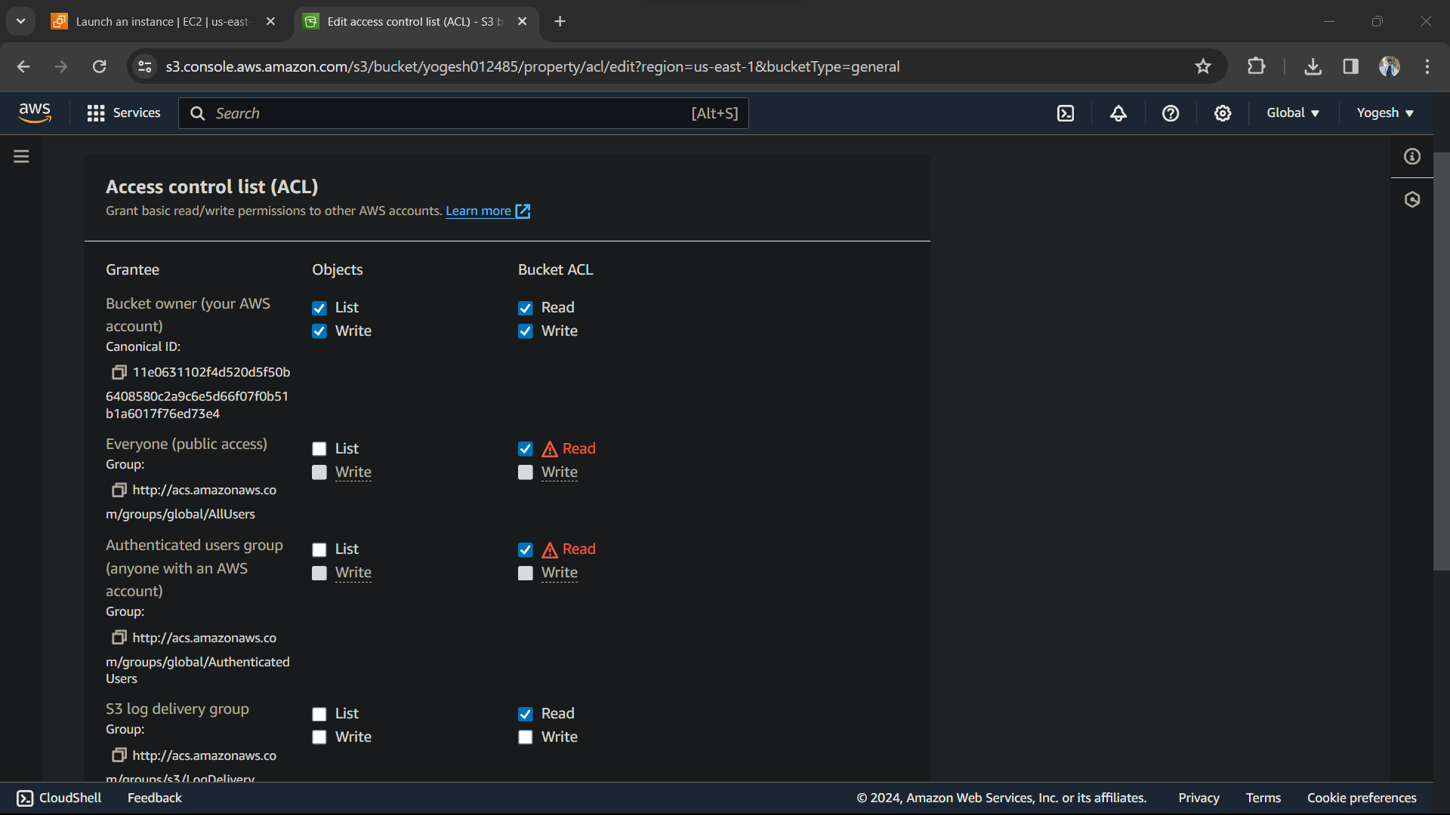

Select Read everywhere and save changes.

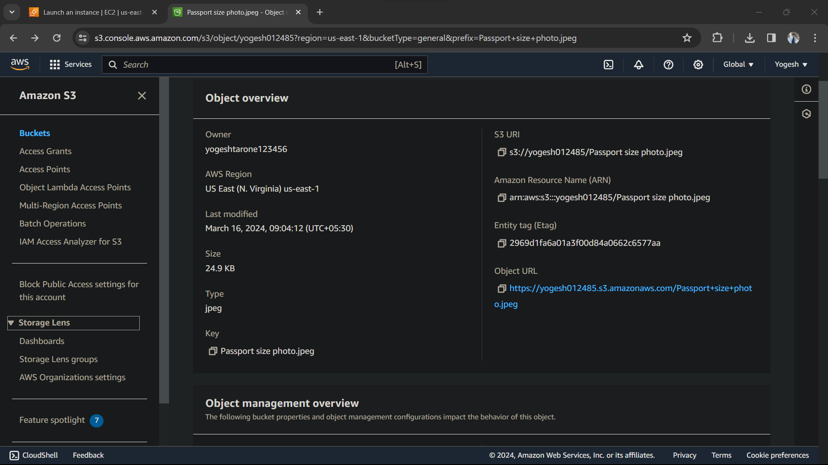

Click on Object URL

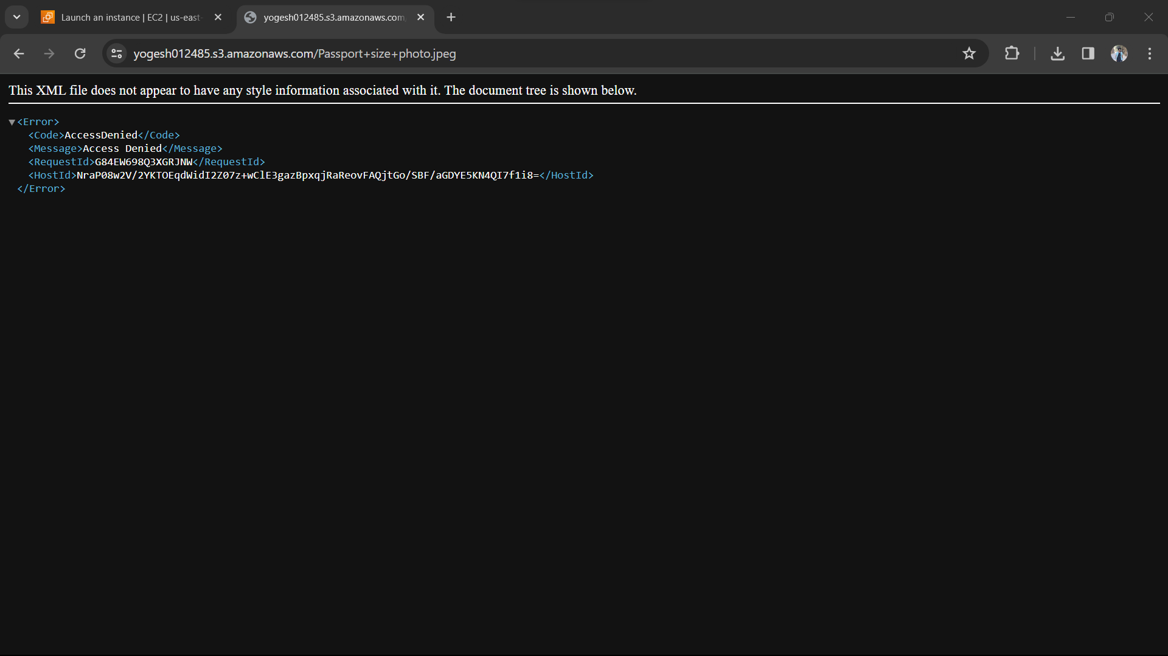

Got this error, so go back to previous page and click on permission

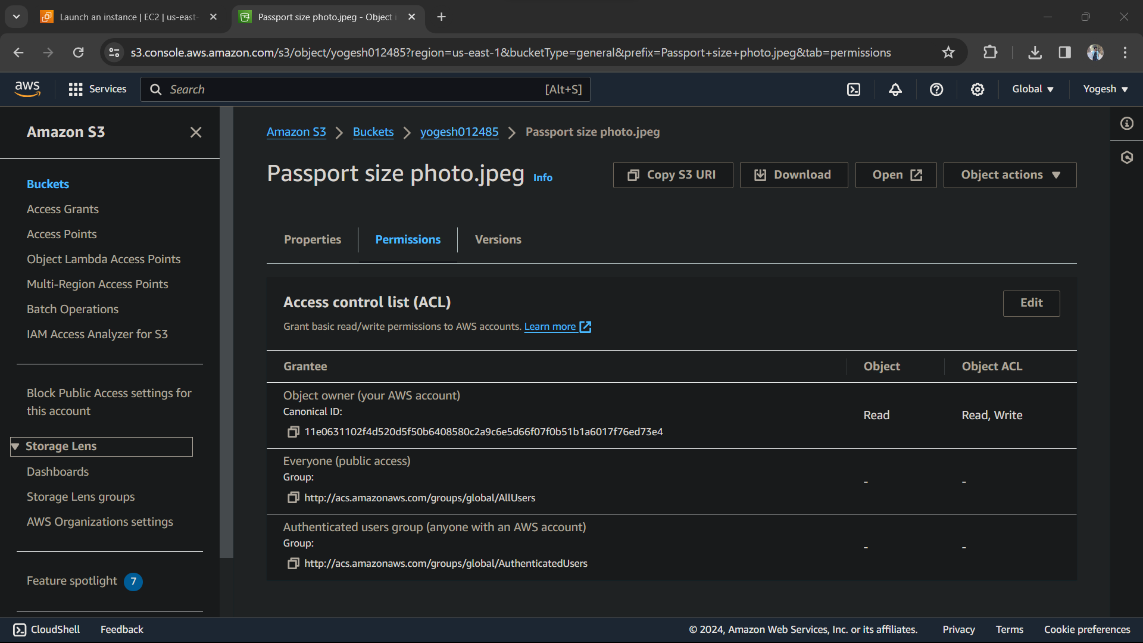

Edit ACL and then select read everywhere and then try again by click on Object URL



Now, its working basically , I can share my link address to anyone and this address will work on other devices as well.

**LINUX**



#!bin/bash

read n1

read n2

read n3

if [[ n1 -gt n2 ]] && [[ n1 -gt n3 ]];then

echo "$n1 is greater"

elif [[ n2 -gt n3 ]]

echo "$n2 is greater"

else

echo "$n3 is greater"

fi

Input : 1 2 3

Output : 3 is greater

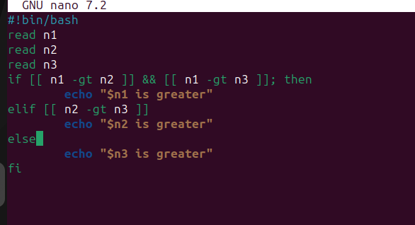

2.

#!bin/bash

read choose

case $choose in

1) date

;;

2) cal

;;

3) ls

;;

4) pwd

;;

5) Exit

;;

esac

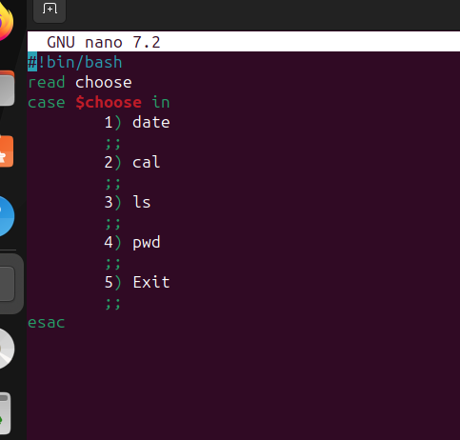

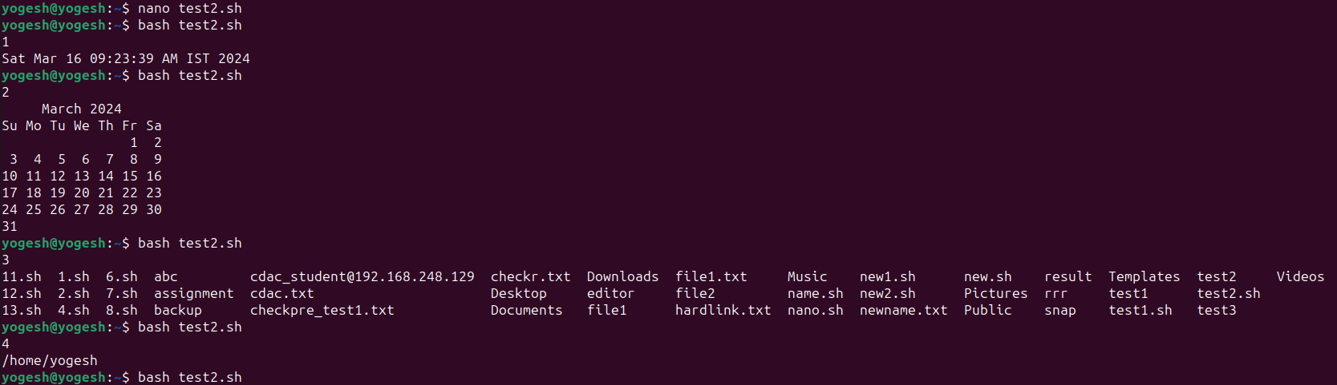

**3.**



**4 commands worked**